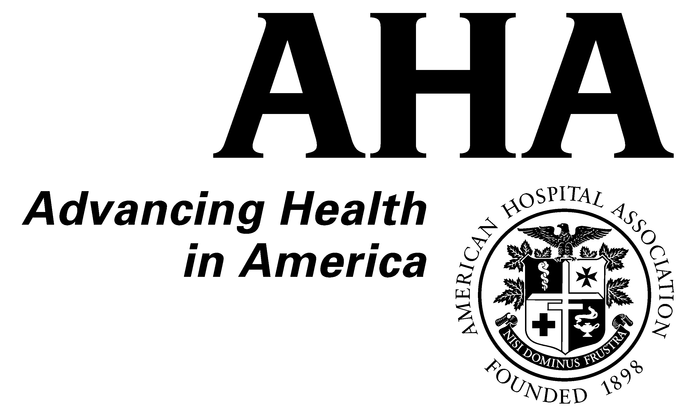

Guiding Principles on Restraint and Seclusion
for Behavioral Health Services
February 25, 1999

Preventing injury and death related to the use of restraint and seclusion is paramount.
The following guidelines are based on the policies already in place in our member institutions. By publicly issuing these guidelines, the American Hospital Association (AHA) and the National Association of Psychiatric Health Systems (NAPHS) hope to heighten public awareness about the appropriate use of restraint and seclusion. We are asking our members to use these guidelines to review their current policies and to make sure they are implemented appropriately.
Restraint and seclusion, when used properly, can be life-saving and injury-sparing interventions.
- A patient's overall treatment is based on a comprehensive, individualized treatment plan that includes appropriate patient and family involvement.
- Hospitals and other treatment settings serve individuals with severe mental illnesses and substance abuse problems who are, at times, dangerous to themselves or others.
- Restraint and seclusion should be used as infrequently as possible, and only when less restrictive methods are considered and are not feasible.
- Restraint and seclusion are emergency interventions that aim to protect patients in danger of harming themselves or others and to enable patients to continue treatment successfully and effectively.
Prevention of injury and death is essential.
- Hospitals and other treatment settings must ensure that staff are well-trained and continuously educated regarding the proper use of restraint and seclusion. Detailed policies, procedures, and systems must be developed with input from physicians and other mental health professionals, and they must be understood and followed by all staff. Areas include:
- assessment and crisis prevention techniques
- use of least restrictive methods
- how to employ restraint and seclusion safely (including understanding the risks and benefits of either intervening or not intervening
- a process for continuously reevaluating the need for restraint or seclusion
- a process for continuous monitoring to ensure the patient's safety and other needs are met

- A physician (or other licensed practitioner as permitted by state law) should authorize use of restraint or seclusion in a timely manner. This licensed clinician must be involved in the decision to continue the use of restraint or seclusion.
- Policies and procedures should be reviewed and updated continuously based on clinical outcomes.
- Because these techniques have a potential for causing injury or death, restraint and seclusion policies must be a system-wide resource priority. Adequate allocation of resources and appropriate decision-making guidelines within the institution must be in place.
- Consideration should be given to the safe and appropriate use of medication as an alternative to restraint and seclusion and in reducing the length of any episode.
Appropriate oversight of restraint and seclusion is important.
- Federal protections are in place through accreditation and regulatory bodies such as the Joint Commission on Accreditation of Healthcare Organizations (JCAHO) and the Health Care Financing Administration and should be supported.
- State laws, rules, and regulations enforced through departments of public and mental health and state licensure agencies also protect patients' rights and should be used to assure appropriate use of restraint and seclusion.
- Overregulation based on narrowly defined problems could divert limited resources to bureaucratic activities. Patients are best served when maximum dollars are devoted to appropriate clinical care.
We are committed to preventing injury and death.
- The NAPHS and AHA are committed to working with consumers, families, regulatory and accrediting agencies, Congress, and others to ensure that the systems designed to protect patients are working, and that clear and appropriate guidelines and standards are in place to protect patients and maintain their dignity.
- Together with our members, we must share guidelines and information on appropriate and inappropriate restraint and seclusion techniques issued by clinical and regulatory bodies (such as the American Psychiatric Association and JCAHO). In addition, restraint and seclusion procedures (or any other interventions) that have been found to be best practices or, conversely, have been found to be dangerous should be widely and promptly communicated within the field.

American Hospital Association
Liberty Place
325 Seventh Street, NW
Washington, DC 20004
(202) 638-1100

National Association of Psychiatric Health Systems
325 Seventh Street, NW, Suite 625
Washington, DC 20004
(202) 393-6700

